Question 2.

Image output

W = reshape(W,[32,32,16]);

figure(1);

for r = 1:const
subplot(4,4,r),imagesc(W(:,:,r));
end

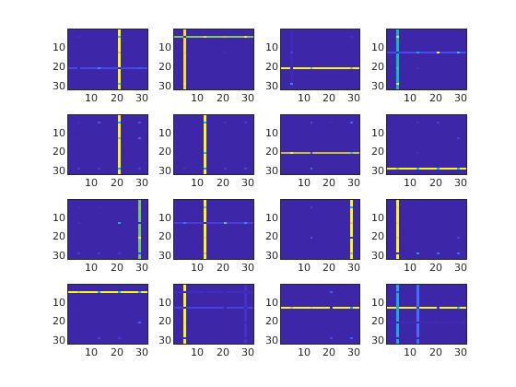
Matrix W

